GenWatt Propane 100kW
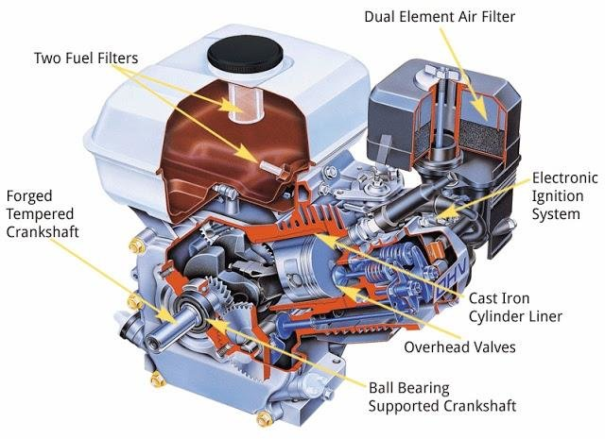
Engine type
4-cycle, gasoline, OHV, cast iron cylinder liners, aluminum block, electronic fuel injection
Model | Command PRO EFI Propane PCV740
HP (kW) ¹ | 24(17)
Displacement (cc) | 45 (747)
Bore in (mm) | 3.3 (83)
Stroke in (mm) | 2.7 (69)
Gross Torque ft lbs (Nm) ¹ | 37.3 (50.6)
Compression Ratio | 9.1:1
Dimensions LxWxH (in)* | 21.3 x 18.5 x 17.6

